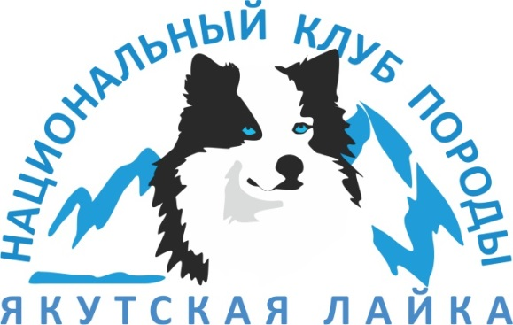

Почтовый адрес: Республика Саха-Якутия, г. Якутск, 677000, а/я 139, телефон – факс 8 (4112) 422-698,
yras@sakha.ru, www.yakutlaika.com , ОКПО 67661053, ОГРН 1101400000921, ИНН\КПП 1435231157\14501001

Stanislav Gorodilov, RKF-FCI Judge

YAKUTIAN LAIKA
(KOLYMA-INDIGIRKA LAIKA, NORTH-EAST SLED DOG)
BREED STANDARD WITH COMMENTS

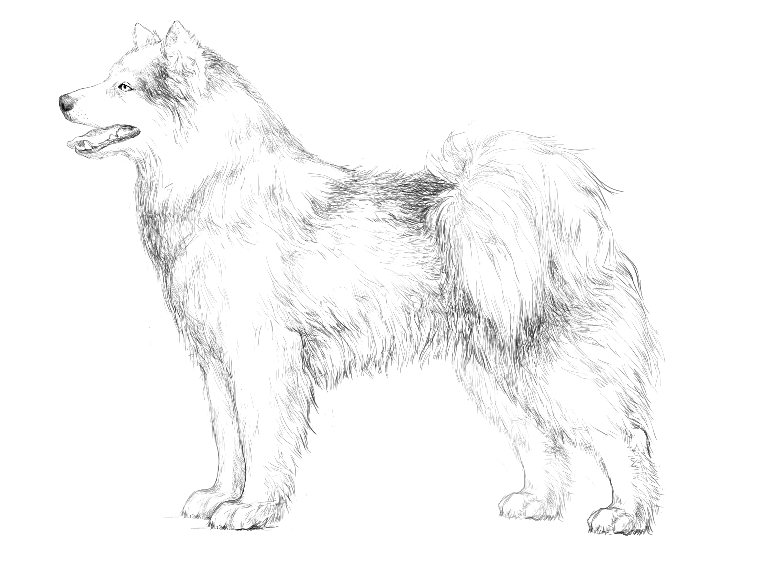

Illustrations made by Elena Protasova
ORIGIN: Russia
DATE OF PUBLICATION OF THE OFFICIAL VALID STANDARD: 00/00/0000
Approved by the Presidium of the Union of Public Cynological Organizations «Russian Kynological Federation» on July 24, 2013
Amendments approved by the Presidium UPCO RKF on September 05, 2018
TRANSLATION: September 05, 2018
UTILIZATION: Sledge and hunting dog
PROPOSED FCI CLASSIFICATION: Group 5 (Laikas and primitive dogs)
Section 1 (Nordic sledge dogs)
With working trials
Breed not recognized by FCI.

BRIEF HISTORICAL SUMMARY: The Yakutian Laika is an ancient native dog breed which was naturally bred by aboriginal people of the North East of Russia as a sled dog and a hunting dog. Certain archaeological discoveries confirm that the local people used dogs for sledding and hunting as far back as 8000 years ago. The very first references about dogs in this region relate to 1633. The first published account of the Yakut dogs was titled “The ways of travelling by Yakutians in winter” which was included in the book “Northern and Eastern Tartary” by Nicholas Witsen (Amsterdam, 1692). The first description of the Yakutian Laika appeared in the book "Geography of the Russian Empire" (Derpt, 1843), which announced it to be a "dog of a special breed”. The first mention of the Yakutian Laika’s total number found in the book "Statistical tables of the Russian Empire" (St. Petersburg, 1856): "There are 15157 dogs in the Yakut region used for sled work". The first Breed Standard for the North-East Sled Dog was adopted in 1958 and it formed the basis for the Yakutian Laika Breed Standard published in 2005 by the Russian Kynological Federation. For many centuries, the Yakutian Laika accompanied the northern man in everyday life, helping him to hunt, vigilantly watch his home, herd reindeers and transport goods in the severe conditions of the Far North. These skills have glorified the Yakutian Laika as a versatile breed not only in Russia but also in many countries on different continents.

GENERAL APPEARANCE: Yakutian Laika is a dog of medium-size, strong, compact, well-muscled, with moderately long legs and thick skin with no signs of looseness.
The coat is well developed and should be sufficient for living and working in severe Arctic conditions. Sexual dimorphism is clearly pronounced, males are stronger and more powerful than females.
Yakutian Laika is a harmonious compact dog with short topline. It is moderately wide, with well-developed chest of good volume, with strong bone, well-developed muscles and elastic ligature.
Sexual dimorphism is well pronounced. A male is always masculine, bigger in size, stronger in bone, with more pronounced withers, bigger head and broader chest. Females are usually longer in body due to longer ischial pelvic bones and more pronounced front. Males have better developed coat with especially pronounced mane on neck and feathering on the limbs.
Poorly pronounced sexual dimorphism both in males and females is considered as a severe fault in the standard and a male in feminine type must be disqualified.
Coat must be thick, with well-developed outer coat and undercoat. But at the same time, the dog must not seem too massive and overweighted due to overdeveloped coat.
Yakutian Laika has no signs of any looseness or lymphatics (dampness). 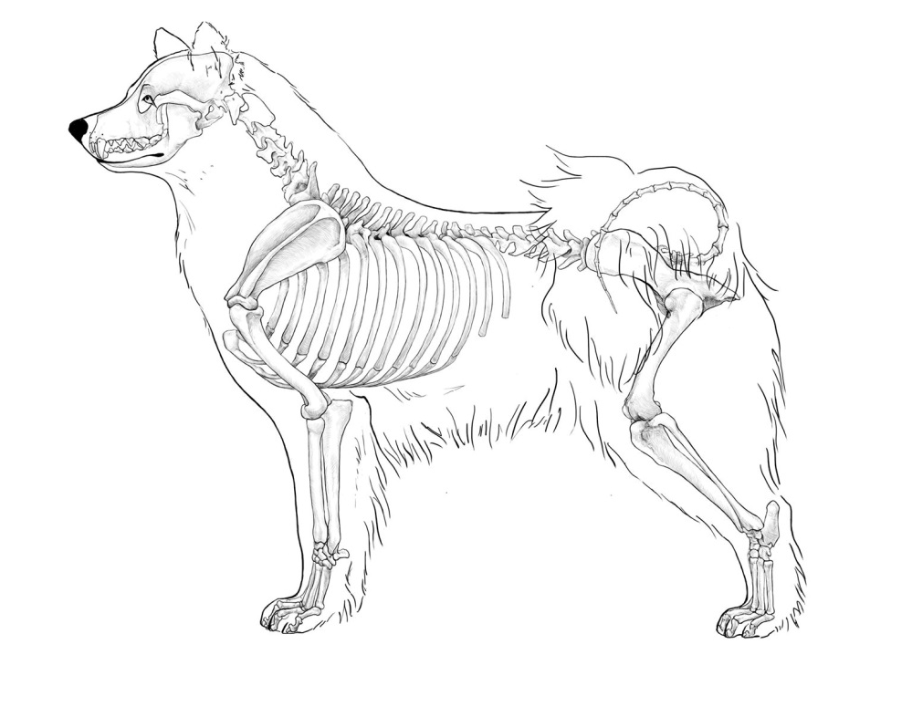
IMPORTANT PROPORTIONS:
- The length of body from shoulder to croup exceeds the height at withers by 10-15%.
The length of body is measured from the front edge of point of shoulder (shoulder-scapular joint) to point of buttock (ischiatic tuberosity).
- The length of the head is a little less than 40% of the height at withers.
The length of head is measured from occiput to point of nose in a straight line.
- The length of the muzzle is 38-40% of the length of the head.
The length of muzzle is measured from interorbital space through inner angles of eyes to tip of nose.
- The length of the fore leg to the elbow is 52-54% of the height at withers.
The length of front leg is not a perfect term. It means height at elbow (elbow joint) in relation to the ground.
It is important to mention that figures in the Standard are mostly approximate. And the best examples of the breed may have them different, e.g. modern dogs’ heads, especially in males, are longer.

BEHAVIOUR/TEMPERAMENT: Yakutian Laika is bold, agile, contact, friendly, sociable and energetic dog.
Behavior and temperament are very important. Any sign of aggressiveness or shyness must be considered as a disqualifying fault.
HEAD: Wedge shaped, moderately pointed, in proportion to dog’s size.
CRANIAL REGION:
Skull: Moderately broad, slightly rounded, with a high forehead.
Cheeks: Moderately pronounced.
Stop: Well pronounced.
It is necessary to point out, that Yakutian Laika’s skull differs from other laika types’ skull. It is more rounded and broad, but not like Samoyed’s. Its shape is slightly convex with moderately pronounced cheekbones, high, moderately broad forehead and a pronounced stop. In general, the head of the Yakutian Laika is quite large.
Flat, dome-shaped, narrow skull with forehead not high enough and flat stop is a severe fault.

FACIAL REGION:
Nose: Of big size, with wide nostrils, black or brown in color.
Normally nose of a healthy Yakutian Laika must be black.
There is a well-founded opinion that the intensity of pigmentation, nose, mucous, skin and coat in particular testifies to the dog's health, its strong immunity and resistance to various allergens.
Pigmentation in general, including skin, coat, and iris of eye pigmentation is linked to the state of the dogs' neural system, its viability.
The color of the nose is determined by the content of pigment melanin in special skin cells (melanocytes). Due to melanocytes pigment reduction the coloration of nose begins to change - lighten up, getting brown.
A so-called "winter nose" often appears after winter, which is associated with a partial loss of pigment under the influence of the natural seasonal factor.
Brown nose of Yakutian Laika is OK only for brown-white and white-brown dogs.
Yakutian Laika also may experience partial depigmentation of the nose. But this is not a desirable norm. However, dogs of spotted colours, especially with white heads, sometimes have partial depigmentation of the nose, eye rims and lips. In general partial depigmentation does not affect dogs' health and working abilities. In breeding programs one should seek for better pigmentation.
There is also a Yakutian Laika characteristic feature - nose, lips, and sometimes eye rims become pigmented only by 1.5 years. Fully depigmented nose is evaluated by the Standard as a disqualifying fault.

Muzzle: Well filled under the eyes, wedge-shaped, gradually tapering towards the tip of the nose.
Lips: Dry, tight-fitting, well pigmented.
Dog’s muzzle should be moderately short (the length of muzzle is 38-40% of the length of the head), of good volume, well filled under the eyes, wedge-shaped, gradually tapering towards the tip of the nose, with a straight nose bridge.
The faults is a short muzzle, often accompanied by undershot jaw. If the muzzle is too long, usually the dog does not have a pronounced stop.

Jaws/Teeth: Teeth are of big size, white, preferably in a complete set (42 teeth according to the dental formula). Scissors bite or level bite. A tight undershot is acceptable for dogs older than 3 years.
On accessing Yakutian Laika teeth formula and bite it is necessary to take into consideration dog’s age and living conditions. Usually Yakutian Laikas live and grow in severe climate conditions. And throughout the breed history no selection by number of teeth and bite was held.
At judging, you should prefer dogs with full dentition and a bite described in the standard. But this should not be the main purpose of examination, because at this stage the breed is forming, and dogs, which have absence of P1 and P2 or blunt incisors under age or even bite before 3 years are bred, although these features are not desirable.
Undershot and jaw misalignments are disqualifying faults.
While breeding it is necessary to strive for scissor bite.
As for jaws themselves, they should be rather wide to give space for correct bite.

EYES: Set straight and wide apart, but not deep set, almond-shaped.
Eye set can say a lot about the shape and size of the skull. If the head is of correct shape, eyes will be rather wide apart. If the skull is narrow, eyes will be set close to each other.
Eyes colour is dark brown, or blue as well as odd eyes (one brown, one blue) or blue segments on brown iris. Dry, tight fitting eye rims matching the colour of nose. Depigmentated eye rim against white background permissible.
It’s necessary to remember that eye color itself is of minor importance. It is necessary to evaluate eyes in complex: shape, set, dryness, eye rim pigment and color.
Preference should be given to eyes of almond shape set straight and wide apart, of brown or blue color or of different color with dry pigmented eye rims. It is worth pointing that brown color is preferable in relation to blue and dark brown preferred light-brown.
Eye rims are dry, pigmented or partially pigmented for light colors; color of pigment is the same as color of nose.
Completely depigmented eye rims and lips are disqualifying faults, but you should not disqualify a dog for partial depigmentation.
How did dogs with blue eyes appear?
This question has always been interesting for researches and kynologists.
- Dogs, originally brought from the Arctic North of Yakutia had blue eyes. And they can be regarded as the ancestors of the breed.
- The inheritance (genetics) of blue eyes is not studied well. The author thinks that the Yakutian Laika's blue eyes appeared long ago as a result of mutation of unknown origin, which nowadays is not studied.
- As for Chukotka and Kamchatka Laikas, Eskimos dogs and other Yakutian Laika close relatives, who can occasionally have blue eyes, the feature is not considered desirable at those breeds. The native people of Chukotka, Kamchatka and Alaska believed and still find dogs with blue eyes as aesthetically unpleasant and they always culled such dogs.
- It can be assumed that blue eyes of Siberian Husky are due to such eyes at Nordic dogs exported by Americans from Kolyma, Chukotka and Kamchatka during the late 19th-early 20th centuries and which were used for producing the Siberian Husky breed.
- From the research experience of Kolyma-Indigirka Laikas, considered as the ancestors of the Yakutian Laikas, we can conclude that blue eyes do not affect its working qualities and health.

EARS: Of triangular shape, set high, wide at the base, thick, erect or tipped. Ears covered with thick, short hair. Ears laid back while moving.
Ideally, when seeing from the front, if you draw a line between the tips of the ears and nose, we should get the isosceles triangle. The ears should be symmetrical and of the same position, the size should be in harmony with the head size and overall appearance of the dog.
Occasionally there are dogs with tipped ears; this ear set is acceptable, but not desirable. Erect ears are preferable.
Yakutian Laikas’ ear set have a number of features typical for this breed:
1. Ears get erect very late (sometimes only by 8-9 months).
2. One may breed dogs brought from the northern territories, where there have been no selection to erect ears. Erect ears does not affect working qualities of dogs.
3. Ears can be covered with overgrown coat that prevents them from being properly erect.

NECK: Of moderate set and length, muscular.
When watching the Yakutian Laika in profile the neck line from the occiput seamlessly connects with moderately pronounced withers. The dog must not have a break where the neck falls into withers. Short or too long neck is a fault for working dogs. Normal neck angle to the horizon is 45-50 degrees.

BODY: Compact.
Yakutian Laika has a well-developed body, ribs are moderately sprung.
Severe fault: short or square dogs.
While judging, it is important to remember that Yakutian Laika is a dog who must bear hard and prolonged physical exercise, and therefore there is a need to pay attention to a compact body, the development of muscles and strength of ligature.

Top line: Straight and firm, with a very slight slope from moderately pronounced withers to the base of the tail.
Topline is solid, short, with moderately pronounced withers.
A small slope from the withers to the tail, i.e. a little high in front - is an important feature of Yakutian Laika standard.

Back: Firm, wide, straight, muscular.
There is no direct indication of the length of the back in the Standard. Meanwhile the length of the back is a significant characteristic, as it corresponds to the length chest, without which the Yakutian Laika will not possess the necessary volume of lungs and healthy heart, located in the chest. The requirement of its large capacity can be achieved by the length, depth and width of the ribcage. However, the excessive width of ribcage will impede the movement of the forequarters on trot.
As a result, the volume of the ribcage can be ensured only by its length and depth. Obviously, the thoracic section of the spine in this case should be half of the topline.

Loin: Short, wide, muscular.
Short loin ensures the integrity of the topline, necessary for best transmission of drive from hindquarters to the front. Development of its muscles allows the loin to carry out its function of the spring in the best way. Strength, power and elasticity of the loin are important qualities, preventing the emergence of soft back and pacing. The length of the loin should be approximately half the length of the back.

Croup: Wide, muscular, long, rounded, almost horizontal.
The width of the croup is determined by the width of the pelvis and the development of muscles. A wide croup and well-developed ischiadic bones, hindquarters movements are free with a good drive.
Narrow croup, on the contrary, leads to restrained movements of hindquarters, which, moreover, do not have sufficient drive if ischium is not sufficiently developed.
When measuring modern Yakutian Laikas we see that the upper part of the croup - the sacrum - is equal to the length of the loin. Here it should be noted that the length of croup is ensured by ischial pelvic bones. Females have extra length of them and that provides them with the reproductive function.
According to the Breed Standard croup should be almost horizontal. The word "almost" is a very important clarification, since Yakutian Laikas' croup should not be absolutely horizontal (flat).
If croup is horizontal, hindquarter angulation usually straightened, steps tend to get shortened, there is a typical trend to get high in rear. The drive function is weakened. So, it is clear why the croup should be slightly sloping.

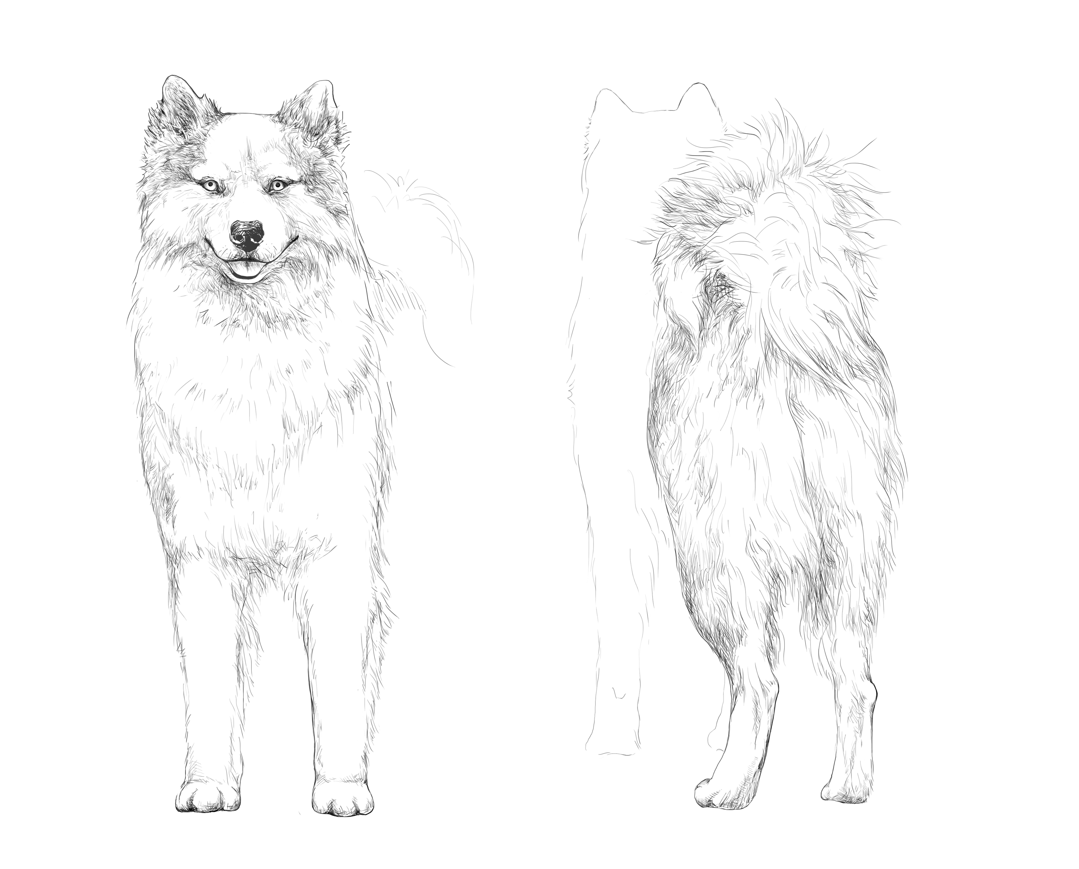
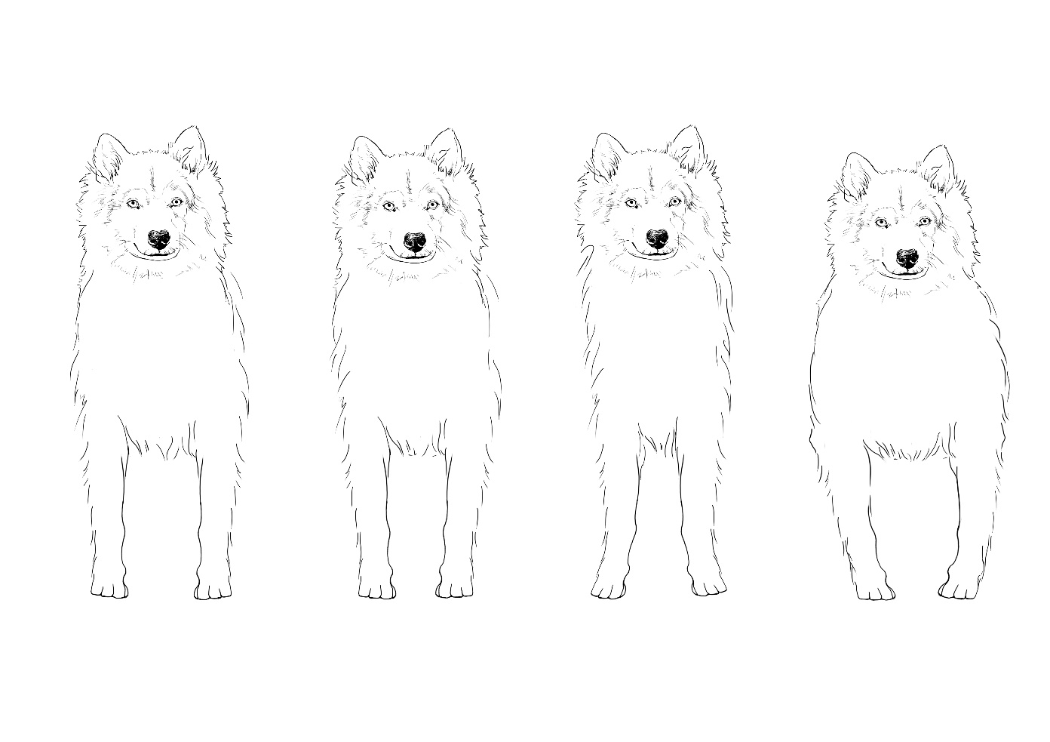
A B C D
RIbcage: А – Normal, B – Oval, С - Narrow, D - Too wide, barrel
Chest: Broad, rounded in cross-section, with well sprung ribs, long enough, moderately deep.
Underline: Belly reasonably tucked up.

The standard states Yakutian Laika’s chest as wide. Width of the chest should not be excessive because a too wide (barrel-shaped) chest will prevent forequarters of the dog from sustained movements.
As it was already said, the ribcage of the Yakutian Laika should be long. Working dogs need a capacious chest to place heart, lungs and major veins.
Yakutian Laika's chest almost reaches the bottom of the elbows that allows the elbows lean on a chest bone and move parallel to the axis of motion. In case of shallow chest elbows acquire extra degree of freedom and can "hang out" on the move, i.e. deviate on sides, that lowers effectiveness of the movements.
Yakutian laika’s chest is rounded in cross-section and has moderately sprung ribs. Chest shouldn’t be either barrel or flat on sides.
The front of the chest of the Yakutian Laika should be moderately convex. It is necessary to increase its lateral surface, which can give space to longer shoulder and upper arm bones, which are able in this case to create a better angulation of the gleno-humeral articulation.
Development and volume of the ribcage are related to the endurance and strength of a working dog. Any deviations in the direction of a deeper or shallower chest must be regarded as a fault. And a flat or barrel ribcage should be regarded as a severe fault.

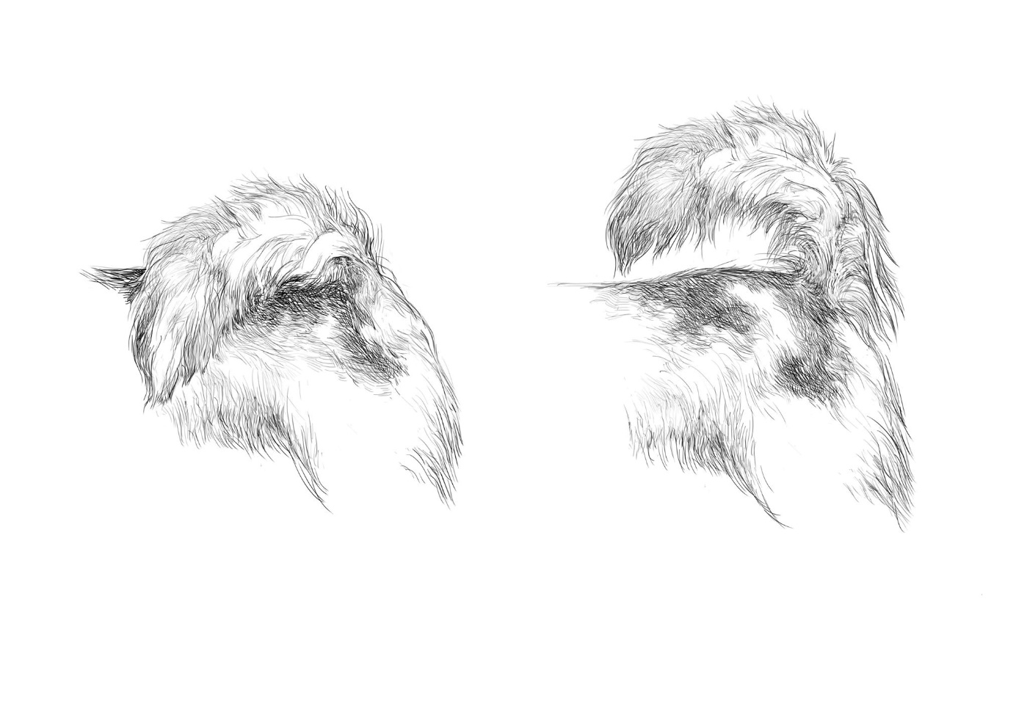
Tail: Set high, covered with a thick furry coat, curled up as semi-circle on the dog’s back, sickle curve tail allowed. At rest or in long distance movement tail may hang loosely.

The tail must be long and elasic along the whole length. While judging it is necessary to examine it on breaks, length and possibility to straightening. This demand is caused by the fact, that the tail that lacks elasticity (in a tight curl) or a tail with poorly developed coat is easily injured and frozen.
Ideally Yakutian Laika’s tail must be high set and curled on the back in semi-circle, saber-shaped tail allowed. Tail may hang loosely during long distant sledding or if the dog is calm.
Main faults in tail structure and set: short tail, break of tail, low tail set, tail in a tight curl.

LIMBS: Strong, muscular, straight, parallel.
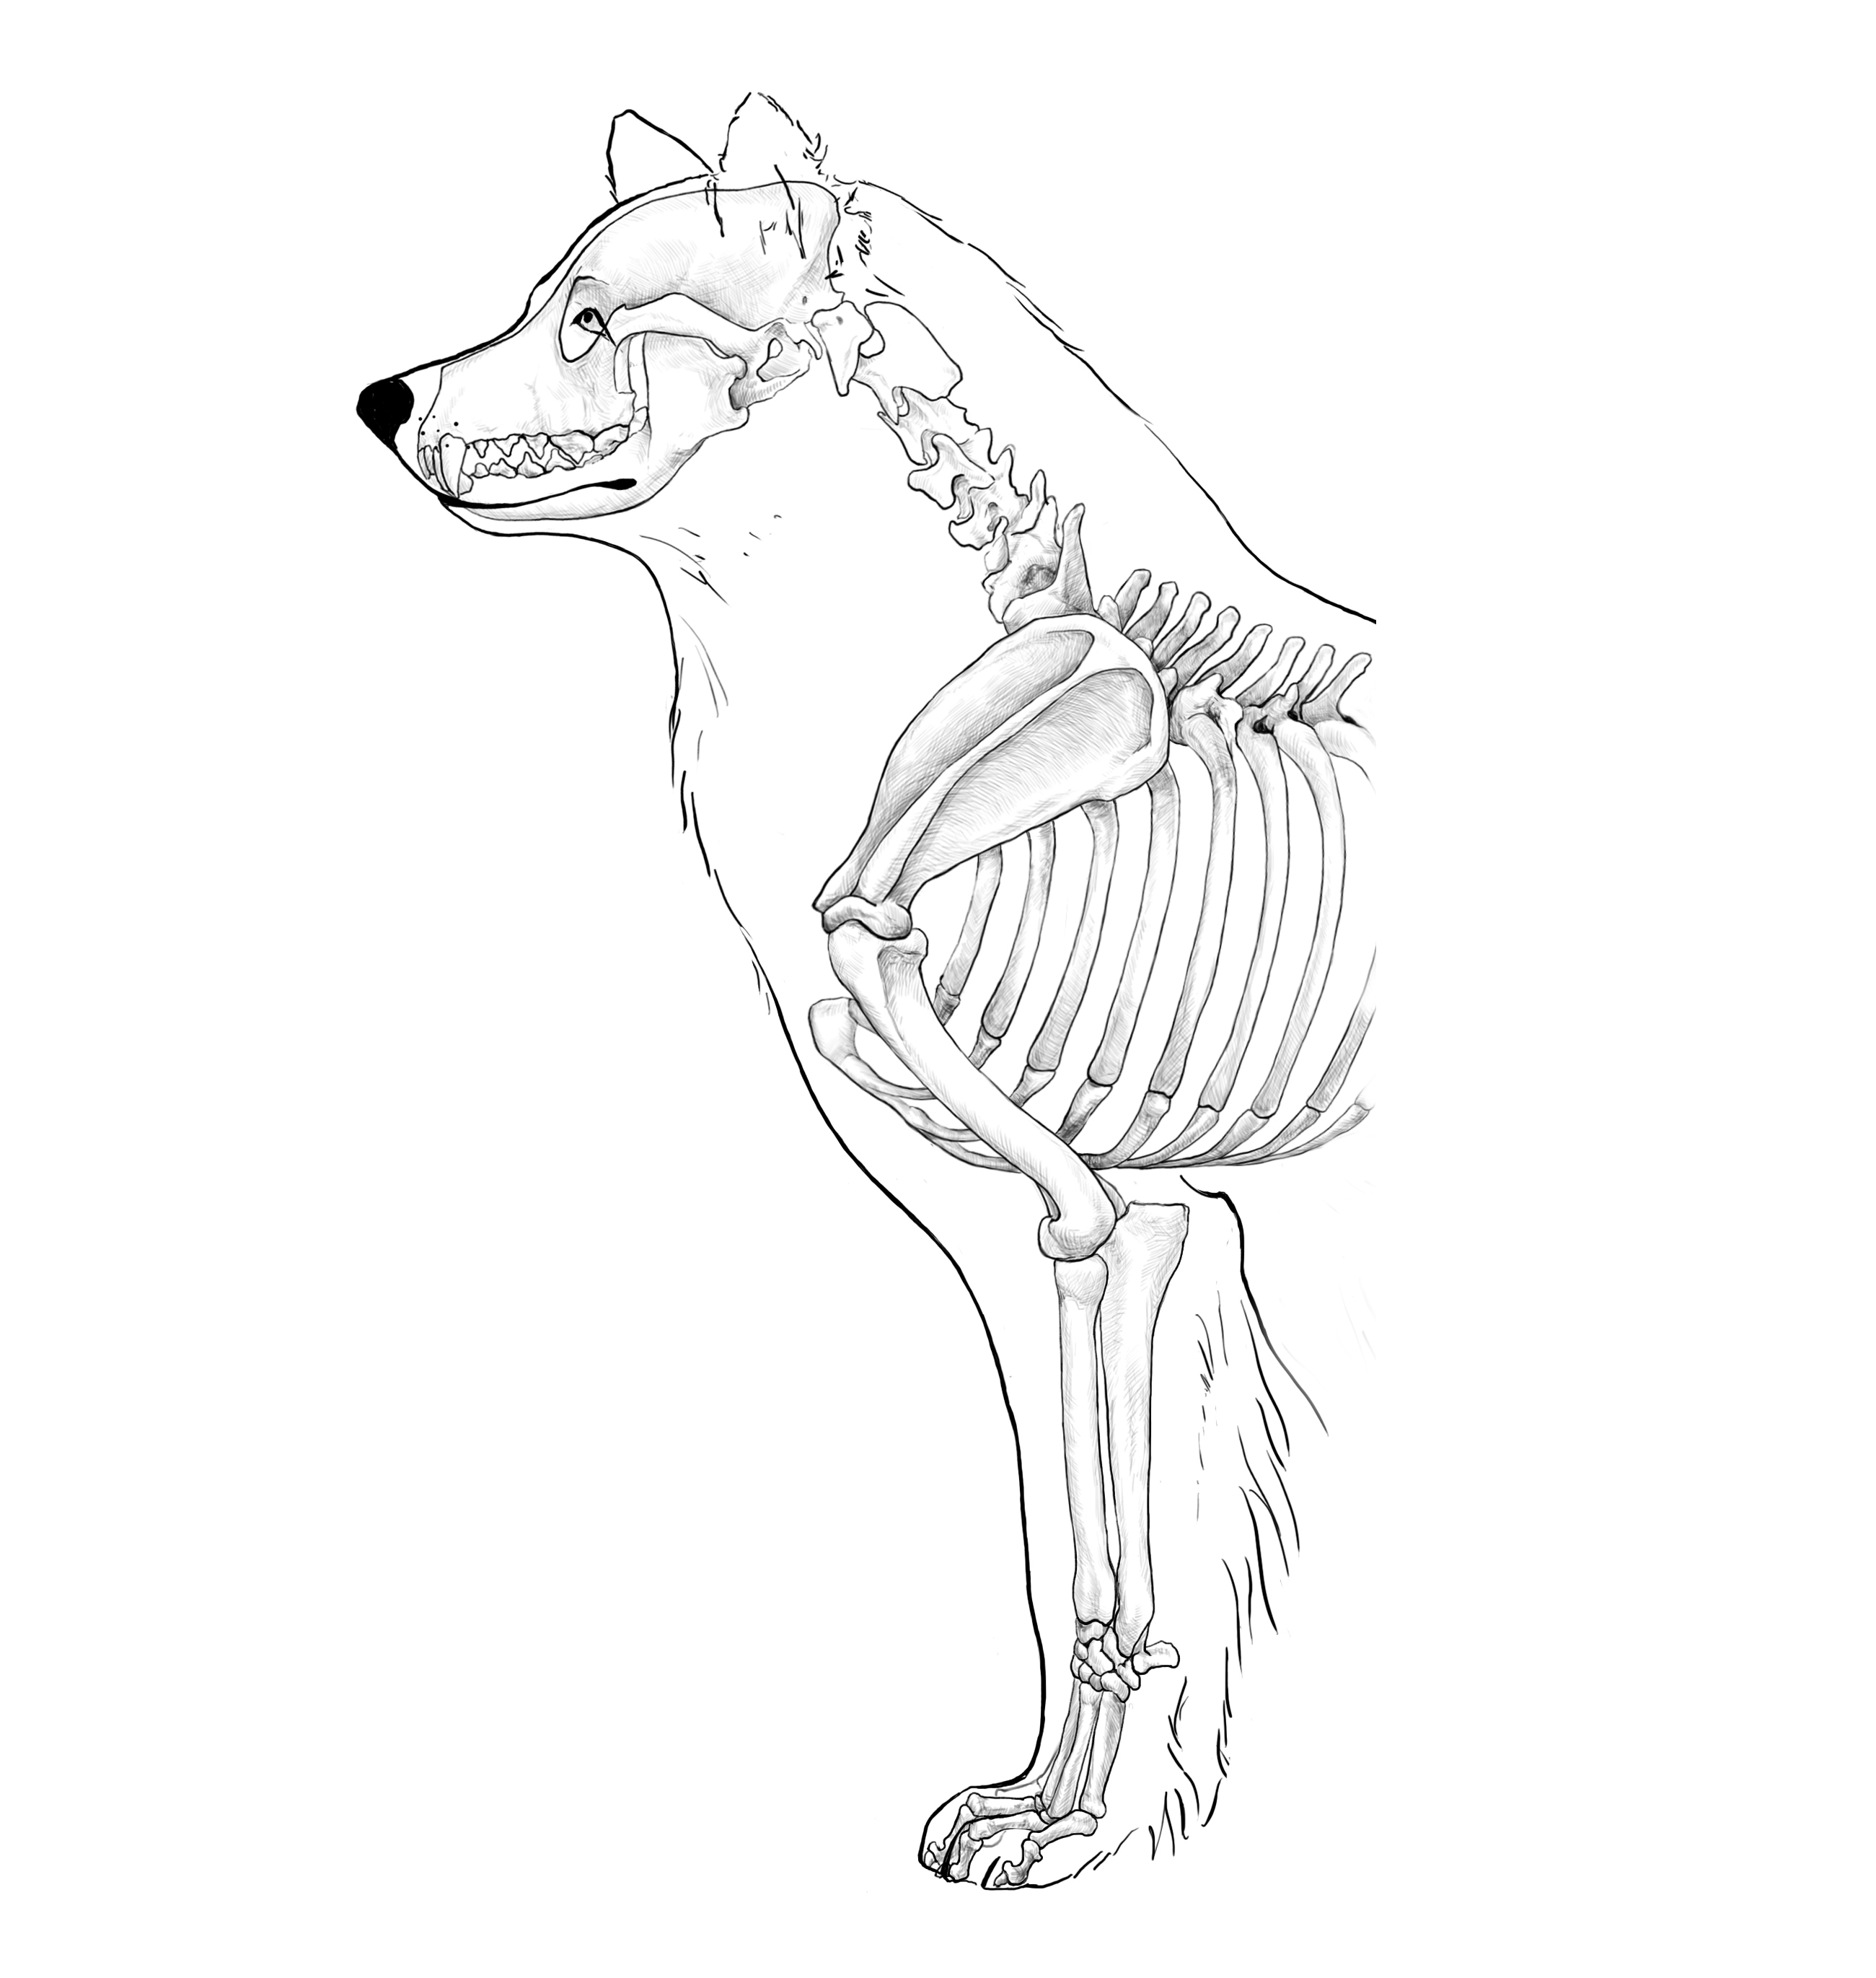
FOREQUATERS:
General appearance: Straight, parallel, strong, very well muscled.
Like for majority of breeds, the main faults are lack of parallel, narrow front, toes out, toes in, inverted legs and loose elbows. Forequarters should be absolutely parallel when looked from the front.
As for hindquarters, they should be moderately wide, it is connected with wide chest of Yakutian Laika.

Shoulder: Sloping, of moderate length.
The length and lay back of shoulder are very important for efficient movements. Shoulder blade should be of enough length to allow long steps of forequaters, i.e. for a reachy action trot. Moreover, lay back of shoulder corresponds to the length of withers.
Short and straight shoulder blade leads to a shorter step of forequarters as well as to a shorter withers and lack of muscles in shoulder assembly.

Upper arm: Muscular, sloping, of moderate length.
Upper arm bone length is almost equal to the shoulder blade. It must be of sufficient length to let elbows reach the bottom of ribcage. Upper arm is set approximately 45-50 degrees to the horizon, i.e. parallel to the neck.

Elbows: Tightly fit to chest, placed back.

Forearm: Rather long, parallel.
Metacarpus (Pastern): Short, strong, slightly sloped.
Pasterns should be strong and short. A small slope of pastern provides cushioning required on landing. It is especially important on the long-term moving on trot. A strong slope of pastern or long pastern weakens ligaments.

HINDQUARTERS:
General appearance: Strong-boned and well muscled. At rear view – straight and parallel.
Hindquarters should not be too wide. Too widely set hindquarters usually lead to an energy loss on moving. Narrow set is also undesirable. It is necessary to remember, that a Yakutian Laika is a trotter dog. It is important to avoid loss of energy when on the move. Due to that quarters shouldn’t differ from the axis when moving at high speed.
It is also important that front and hind quarters’ angulation matched each other that lead to balance on the move. Ideally, the stride of forequarters should be equal to the stride of hindquarters.

Thighs: Broad and muscular.
Very little is said about the length and set of thighs in the standard however this factor is very important. A thigh should be long and oblique.
Normally a thigh is perpendicular to the bones of the pelvis and hips angle is about 100 degrees relative to the horizon. This structure provides a good angulation of hip joints and a wide step of hindquarters.
Normally, the thigh is of a correct length when shoulder and hip joints are at the same level; and elbow and knee joints are also located on one horizontal line.
Such structure provides to the horizontal topline, which doesn't make a dog work on lifting the center of gravity in motion and at which the drive from the hindquarters to the forequarters along the topline transfer in the most efficient mode.
Short thigh usually leads to high back end.

Stifle (Knee): Well defined.
A thigh is connected with a lower thigh and forms a knee angle joint which is approximately 115-120 degrees.

Lower thighs: Of medium length, strong. Hock joints angulation is well defined.
Normally a lower thigh should be equal in length to a thigh.
Lower thigh angulation is about 45-50 degrees to horizon. So, in stack a Yakutian Laika should have a lower thigh (up to a vertical rear pastern) parallel to an upper arm and a neck.
Hock joint, connecting lower thigh with a rear pastern must be well defined and be about 140 degrees.

Metatarsus (Rear pastern): Strong, vertical.
While looking from the side, a rear pastern must be vertical.
While looking from the back, quarters should be moderately wide, and rear pasterns should be parallel.
Any deviations from vertical and parallel rear pastern set break the stability and cushioning function.

Feet (front and rear): Well arched, tight, with very hard pads and thick coat (brush) between toes. Hind feet are slightly bigger than the front feet.
Yakutian Laika's paws should be oval, tight due to close-cupped toes.
While seen from the side, Yakutian Laika’s paws look high, arched.
Loose paws with widely spaced toes springs bad and prone to injury.
Flat paw due to straight toes loses cushioning function that leads to extra stress on the joints and their injuries.
Hard pads and thick coat on paws has a protective function. Harsh climatic conditions in the native regions of the breed: cold, snow, ice make specific requirements for the paws of Yakutian Laika. The main one is protection from injuries and frostbite.
All in all Yakutian Laika's paws should be sufficiently large, compact, with muscular toes and well protected with coat.
The standard does not mention of the claws of the Yakutian Laika. Naturally due to the paws, claws of Yakutian Laika should be thick in structure, curved and directed tip to the ground. It should be said also that the color of the claws, as well as the color of the pads should ideally be dark.

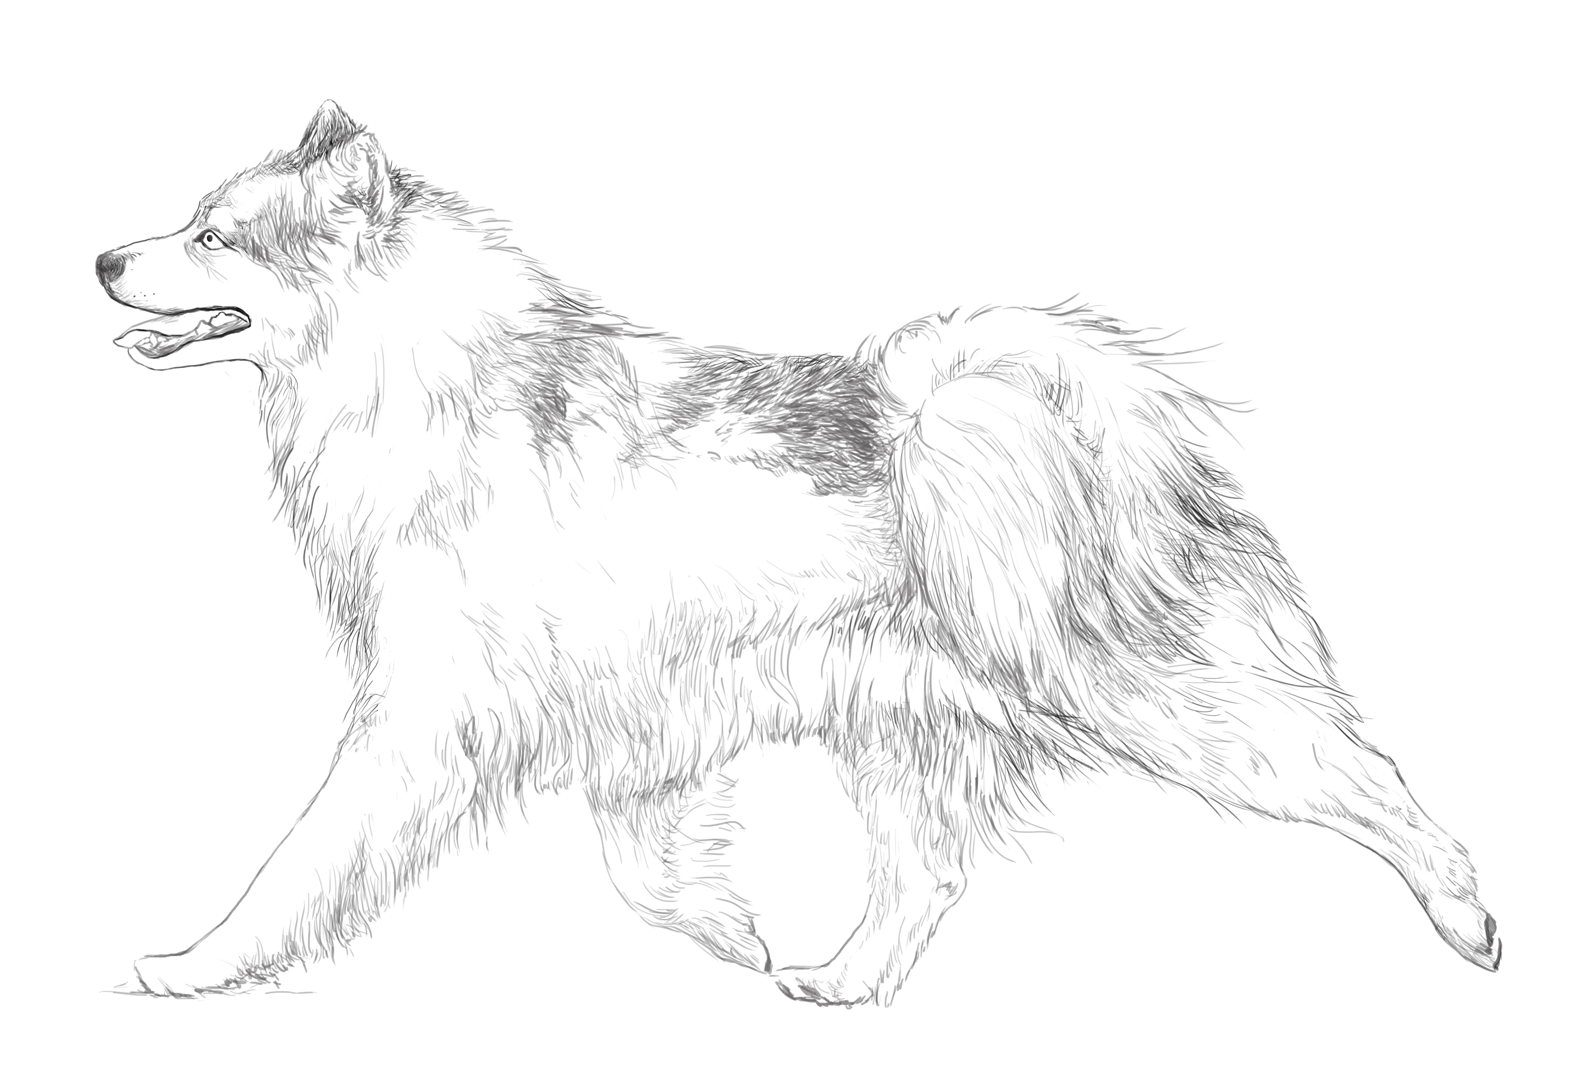
GATE / MOVEMENT: Fast, elastic. Characteristic gaits are brisk trot and gallop.
To evaluate to the exterior, balance, physical condition and temperament of the Yakutian Laika, it’s necessary to pay special attention to function and efficiency of their movements.
Yakutian Laika is a sledge breed created for long distant sled working with less energy efforts. Yakutian Laikas are neither sprinters nor stayers, they are marathon runners. Ideally Yakutian Laika must move freely. Its movements should be free and the dog shouldn’t spend much effort to move forward.
The characteristic gait is brisk trot.
Trot is the fastest and most power saving gait for a dog. It should be said that Yakutian Laika can change character of movements, transferring to gallop when effort is needed. It usually happens when the dog, harnessed to a sledge, start moving. They don’t use that gait long, after gaining speed they transfer to trot.
In motion all the parts of the dog interact, and that is why the balance of all parts is essential. Poor balance, sluggish movements are a fault.

COAT:
Hair: Thick, glossy, straight, coarse, of medium length, with very well developed thick and dense undercoat. On the neck it forms mane, especially clearly pronounced in males; thick feathers on the back sides of the front and hind legs; the tail feathered with a small fringe. Coat is shorter on the head and front sides of the legs.
Yakutian Laika lives in harsh climatic conditions in the historic homeland in the Republic of Sakha (Yakutia). Severe continental climate, very cold in winter and hot in summer, while maintaining low humidity has formed certain requirements for dogs' coat.
Yakutian Laika's coat is thick, of medium length, straight, harsh to the touch with a well-developed dense undercoat. It must protect from cold in winter and heat and insects in summer, there is no need for special care or maintenance of the dog’s coat. In real life mushers and owners of Yakutian Laikas do not deal with special grooming, everything happens in a naturally. In modern conditions, especially when Yakutian Laikas are kept in the homes and untypical climate zones for them, it's necessary to preserve the characteristics coat of the dog.

Yakutian Laikas shed seasonally, shedding is highly pronounced. Summer coat differs strongly from the winter one by length, but it remains thick and quite coarse in structure.
It is necessary to mention that coat (outer coat) should not be too long. On practice the average length of outer coat on males' body is from 5 cm; and to 15 cm on mane and featherings, and it is a little shorter at females'. Excessive coat makes a dog visually heavier and may make grooming more complicated.
Coarseness of coat to the touch is very important. Softer coat easily mats, it is poorly ventilated and does not stay dry.
Yakutian Laika's coat develops quite a long time. At the age of 1.5-2 years dogs have puppy coat: not too long, soft and wooly. And only after 2 years you can definitively say that a particular dog's coat is developed. Usually females' correct (adult) coat develops earlier.
Wavy, soft, too short coat with a poorly developed undercoat consider as a severe fault, and smooth coat is a disqualifying fault.
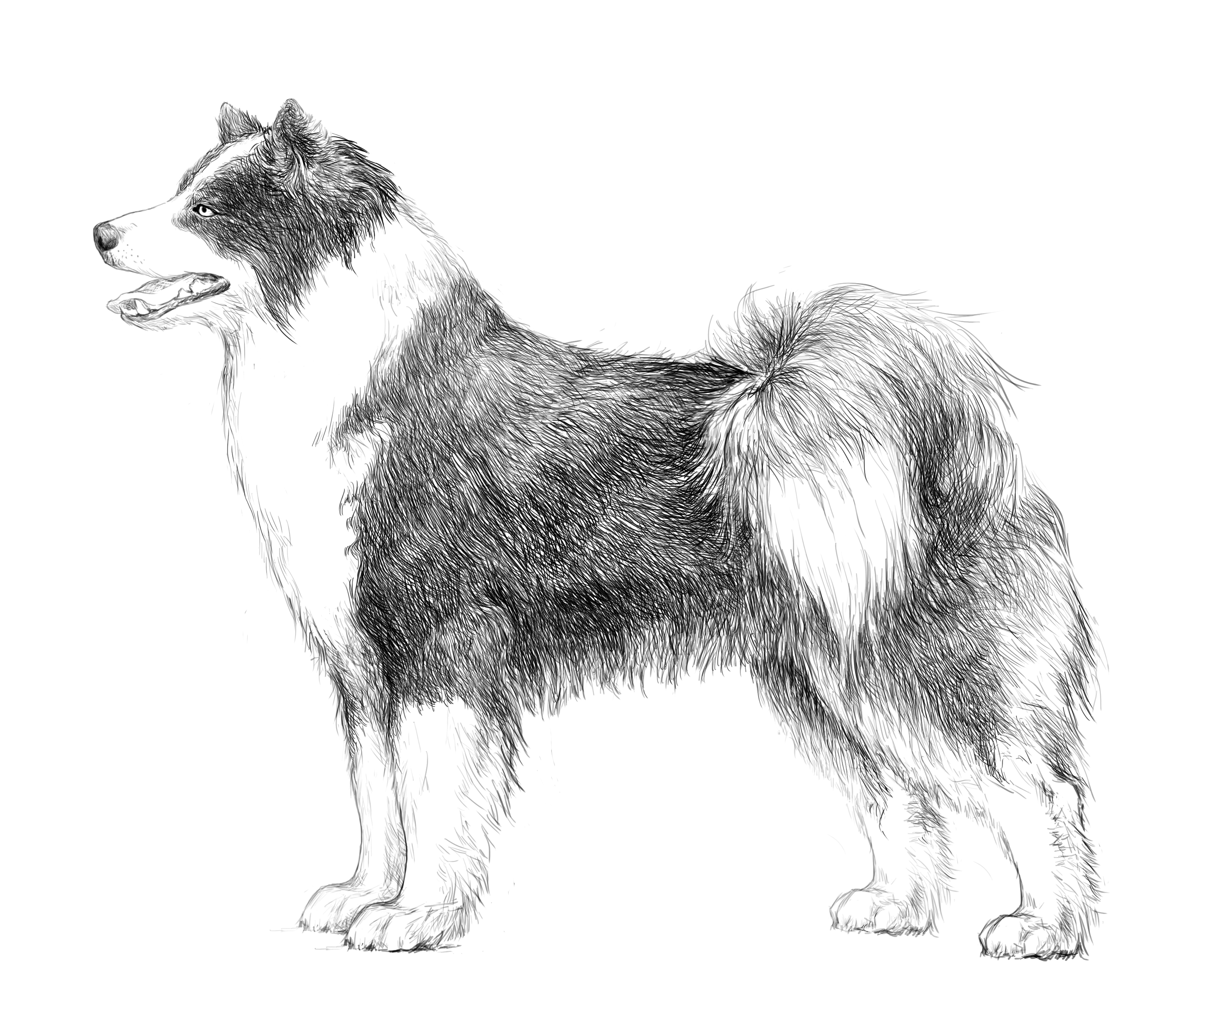
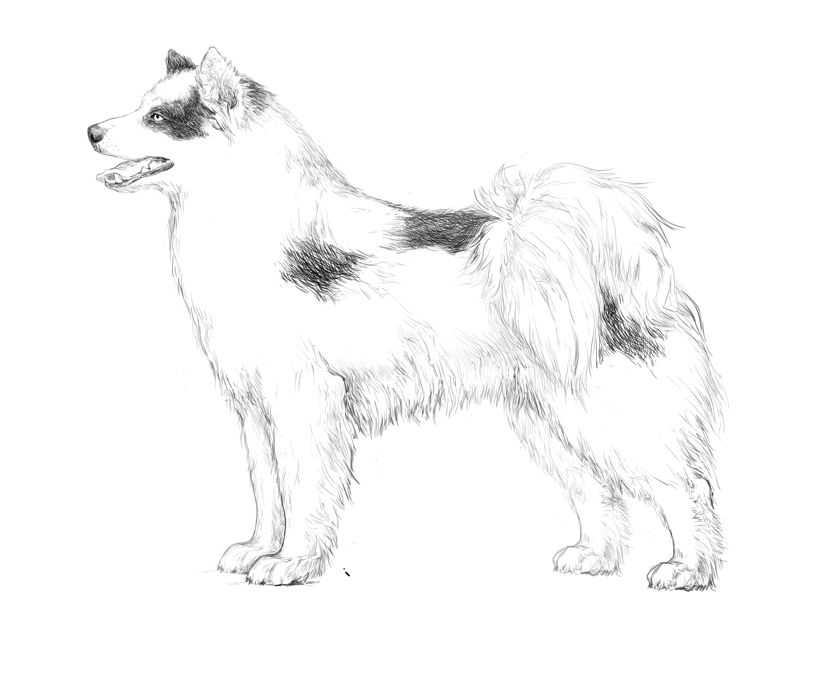
Colour: White and any mixed (double – or triple - coloured).
Yakutian Laika has a large variety of colours, this goes out from the varying degrees of coat colouring due to the formation of pigmented and unpigmented zones. All Yakutian Laikas have a spotted colour, which manifests itself in varying degrees, from solid white to moderately spotted, in which white spots can only be on the chest, legs, muzzle, withers, at the end of the tail.
All Yakutian Laika’s colours may be divided on spottiness degree:
White colour without pigmented spots on the coat;
Spotted – white with some pigmented zones;
Piebald – pigmented with some white spots;
Mantle – pigmented color (type of spotted) with specific coloring. White muzzle with a stripe, dividing the head into two parts, white collar, white throat into white chest and belly, white legs and white tip of tail.
Spotted-piebald – the same quantity of pigmented and depigmented zones.
In all colours nose, eyerims, lips, pads of paws, nails must be pigmented or partially pigmented. Special attention should be paid to the presence of pigmentation on eyerims and lips of white headed dogs.
Pigmented parts of coat may be black, red, grey, tan and brown. There also can be mottles on a white (depigmented) background.
Coloring and pigmented zones may be both asymmetrical and symmetrical.
It is necessary to say, that combinations of grey and white or black and white are mostly typical for Yakutian Laikas. Red or brown combinations with white are very rare. So, in the native regions in Yakutia only few red dogs were born in 20 years of breeding. No brown were born at all.

Сolour | Double coloured | Triple coloured
Spotted – white with some pigmented spots | White with black spots, White and grey, White and red, White and brown, White and black with ticking | White and black and red, white and black and tan, White and black and red with mottle
Piebald – pigmented with some white spots | Black Piebald  Grey Piebald  Red Piebald | White and black and red, white and black and tan, White and black and red with mottle
Extreme Spotting; almost white color. Dark spots may be only in the centers of pigmentation

There are often occur questions with color definition while judging. Young dogs before 1.5 years have black that often looks grey or reddish. And, as it was said above it is necessary to consider age, since Yakutian Laika is late in developing both color and final coat type.

Size and weight:
Height at the withers: Males: preferable height is 55-59 cm.
Females: preferable height is 53-57 cm.

Correct size is very important for Yakutian Laika.
The ideal size for males is – 56 см, for females – 55 см.
Big-heavy or small-light dogs can’s work efficiently in a sledge. Big – heavy dogs will get tired quickly and will spend too much energy on moving. Small dogs with light bone don’t have enough muscle and can’t make enough effort for a long work in a sledge.
At present time of breed development we see two tendencies: first – big high on legs dogs with flat ribcage. Second are small dogs, usually square, with short muzzle, round eyes and too round skull.

FAULTS:
Any departure from the foregoing points should be considered a fault and the seriousness with which the fault is regarded should be in exact proportion to its degree and its effect upon the health and welfare of the dog and on its ability to perform its traditional work.

SEVERE FAULTS:
- A strong deviation from the described type of constitution, short legs;
- Square format;
- Flat, small, or barrel chest;
- Poorly balanced, sluggish movements;
- Wavy, soft, too short hair with a poorly developed undercoat.

DISQUALIFYING FAULTS:
- Aggressive or overly shy dogs;
- Any dog clearly showing physical or behavioural abnormalities;
- Disproportions in conformation;
- Males in feminine type;
- Overshot, undershot with a gap, misaligned jaws;
- Total depigmentation of nose, eye rims and lips;
- Any monochrome colour other than white.
- Short (smooth) hair;
- Any behavioural or constitutional deviations affecting the health of the dog and its ability to perform the work traditional for this particular breed.
N.B.:
- Male animals should have two apparently normal testicles fully descended into the scrotum.
- Only functionally and clinically healthy dogs, with breed typical conformation, should be used for breeding.

